When implementing the SAP system for our manufacturing plant within our Diagnostics division, we dealt with several formulas of chemical reagents that had to be migrated into SAP.

Looking back at the implementation and working through the procurement process to purchase materials needed for reagents, I now realized that this issue could be solved with graphing linear inequalities.

\*To make calculations easier, I have used arbitrary numbers and renamed the contents that go into the reagents as Element A and Element B. Also I’m not a chemist so I have no recollection of what the chemical compound was composed of ☺

The scenario:

Cost for Reagent 1 = $27

Cost for Reagent 2 = $29

Reagent 1 contains:

Element A = 7 Liters

Element B = 5 Liters

Reagent 2 contains:

Element A = 5 Liters

Element B = 3 Liters

Requirements:

* For the diagnostic machine to work, at least 6 liters of Reagent 2 must be used.
* 35 Liters of Element A must be on hand
* 30 Liters of Element B must be on hand

z = 27x + 29y

7x + 5y >= 35

5x + 3y >= 30

y>= 6

How much reagent should be ordered to minimize cost yet meet all the requirements of the lab?

7x + 5y >= 35

solve for y

y >= -7/5x + 7

5x + 3y >= 30

solve for y

y >= -5/3x + 10

y >= 6

x >= 0

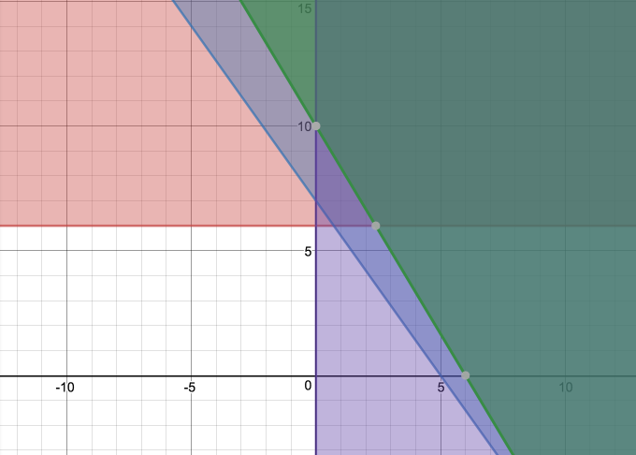

2 points result:

(0,10) and (2.4,6)

z = 27(0) + 29(10) = $290

z = 27(2.4) + 29(6) = $238.8

Minimize cost by ordering:

* 2.4 orders of Reagent 1
* 6 orders of Reagent 2

Discuss the approaches to solving minimization problems versus solving maximization problems. How are they different? How are they similar? Which do you prefer?

The difference lies in what you are looking for based on the problem at hand. For minimization problems, the approach is to solve for the minimum value. So if you are looking at a problem to find the lowest cost of something you would find the minimum cost. If you are looking to maximize revenue, you would use the maximization approach. The approach is similar in that you still use the graphical points to fill into your formula and find the value. I prefer to look at the maximization method for problems, it is easier to recognize when graphing out the inequalities.